1. INTRODUCTION

1.1 IBM POWER SYSTEMS
'Power Systems' is the name of IBM's Power Architecture-based Server series. Initially, IBM had two distinct Power-based lines: the System i running IBM i operating system and the System p series running AIX or Linux operating system. These series were rebranded as Power Systems in 2008.
IBM Power 7 Systems:
Power System 7 is the currently running Server in the Power system series and it runs with Power 7 processor. The POWER7 superscalar symmetric multiprocessor architecture is a substantial evolution from the POWER6 design, focusing more on power efficiency through multiple cores and simultaneous multithreading (SMT). While the POWER6 features a dual-core processor, each capable of two-way simultaneous multithreading, the IBM POWER 7 processor has up to eight cores, where each core is capable of four-way simultaneous multithreading. Hence the power 7 processor has a total capacity of 32 simultaneous threads.
There is a special TurboCore mode that can turn off half of the cores from an eight-core processor, but those 4 cores have access to all the memory controllers and L3 cache at increased clock speeds. This makes each core's performance higher which is important for workloads which require the fastest sequential performance at the cost of reduced parallel performance. TurboCore mode can reduce software costs in half for those applications that are licensed per core, while increasing per core performance from that software.
The POWER7 has approximately 1.2 billion transistors and is 567 mm² large fabricated on a 45 nm process. A notable difference from POWER6 is that the POWER7 executes instructions out-of-order instead of in-order. Despite the decrease in maximum frequency compared to POWER6,each core has higher performance than the POWER6, while having up to 4 times the number of cores.
IBM Power 8 systems:
The Power 8 systems are based on Power 8 processor, which is designed for massive workloads, such as Big Data and other analytics. IBM has announced three new Power Systems optimized for Big Data and other analytics designed to examine and act upon data in real time. The new hardware is embedded with new analytics and Big Data-oriented software -- IBM Solution for BLU Acceleration, IBM Solution for Analytics and IBM Solution for Hadoop.
Power 8 processor is available for licensing under the OpenPOWER Foundation which is a first for IBM's highest end processors. POWER8 is designed to be a massively multithreaded chip, capable of handling 96 hardware threads simultaneously. i.e.) It consists of 12 CPU cores capable of eight threads each for a total of 96 threads per CPU. The chip makes use of very large amounts of on- and off-chip eDRAM caches, and on-chip memory controllers enable very high bandwidth to memory and system I/O.
Each core comes with 512KB of L2 SRAM and 8MB of L3 EDRAM, for a total of 6MB L2 and 96MB L3 cache respectively. Each chip can access up to 1TB of memory with throughput of 230GB/sec. For most workloads, the chip is said to perform two to three times as fast as its predecessor, the POWER7. The chip is fabricated by a 22 nm silicon on insulator process using 15 metal layers, consists of 4.2 billion transistors and is 650 mm² large.
1.2 HARDWARE MANAGEMENT CONSOLE (HMC)
Hardware Management Console is a technology created by IBM to provide a standard interface for configuring and operating partitioned systems and IBM Power Systems. The HMC is a Linux kernel , which utilizes Java applications to provide the needed functionality. The Hardware requirement of the HMC console includes 32-bit Intel-based desktop PC with a DVD-RAM drive. The figure 1.3 shows the view of the Hardware Management Console.
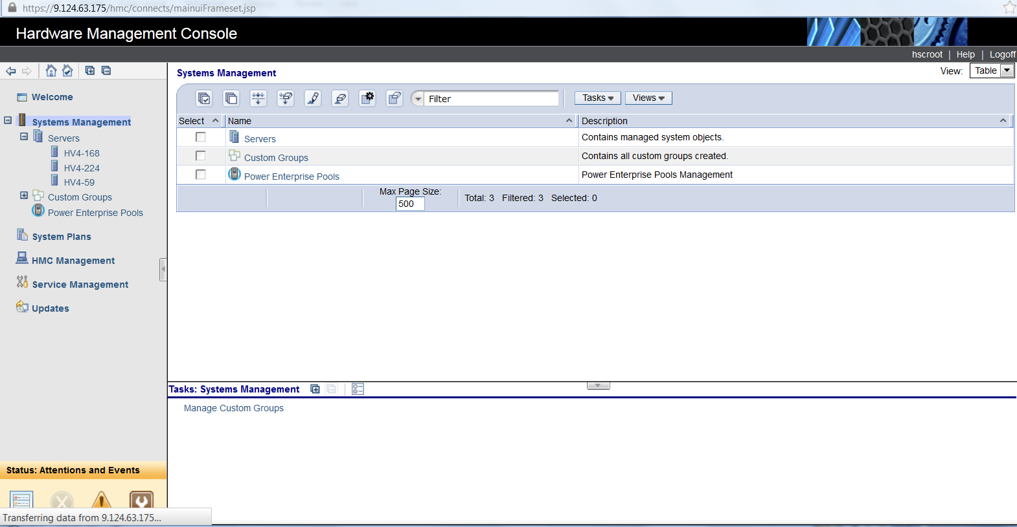
Figure 1.1 Hardware Management Console
The IBM Hardware Management Console (HMC) provides system administrators a tool for planning, deploying, and managing IBM servers .Using an HMC, the administrator is able to manage the software configuration and operation of partitions in a server system, as well as to monitor and identify hardware problems. Using service applications, the HMC communicates with managed systems to detect, consolidate, and send information to IBM for analysis.
HMC is used to:
- Configure and manage logical partitions and partition profiles
- Perform DLPAR functions
- Activate and manage Capacity on Demand resources
- Create import, export, view, create, remove, and deploy system plans.
1.3 LOGICAL PARTITION
A logical partition, commonly called an LPAR, is a subset of computer's hardware resources, virtualized as a separate computer. In effect, a physical machine can be partitioned into multiple logical partitions, each hosting a separate operating system. Figure 1.1 shows the properties of a Logical Partition.
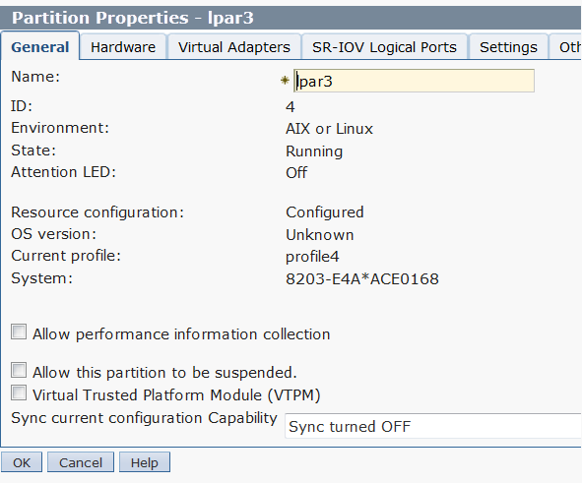
Figure 1.2 Logical Partition Properties
Deploying and managing LPAR on Power servers involves initial planning that determines the amount of CPUs (computation power) and memory to assign, as well as which I/O slots and adapters are needed. Logical partitioning divides hardware resources. Two LPARs may access memory from a common memory chip, provided that the ranges of addresses directly accessible to each do not overlap. One partition may indirectly control memory controlled by a second partition, but only by commanding a process in that partition.
CPU may be dedicated to a single LPAR or shared. A partition must have at least one CPU. Memory can be assigned in increments of 256 MB, with a minimum of 1 GB per partition. CPUs, memory and I/O devices are assigned to partitions in the definition phase. The figure 1.2 shows the configuration of a Logical Partition. Partitions are defined and managed from a unit called Hardware Management Console.
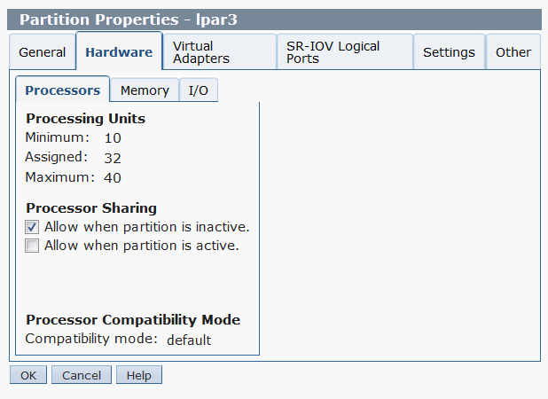
Figure 1.3 Configuration of Logical Partition

2. OBJECTIVE OF THE PROJECT

Live Partition Mobility involves moving the active logical partition(LPAR) from one server to other servers, for serving purposes like server maintenance, load balancing, energy consumption etc. In case of server maintenance, all the logical partitions in the server to be maintained, have to be migrated to other servers quickly. But currently Live partition mobility is mostly carried out with individual LPARs through REST jobs (i.e. only one LPAR can be migrated at a time). Migration will be efficient if all the logical partitions are migrated at once to the destination servers. Hence the objective is the Live Partition Migration of all Logical Partitions of a server simultaneously to different destination servers through REST jobs.

3. LIVE PARTITION MIGRATION ARCHITECURE

Live Partition Mobility is a chargeable feature of IBM POWER6 and POWER7 servers, available since 2007, that allows a running LPAR to be relocated from one system to another. Live Partition Mobility is carried out to avoid outages for planned server maintenance, for load balancing across multiple servers and for energy conservation.
The source and target systems must have access to the same network and SANs but need not be of the same type, the only requirement is they use POWER6 or POWER7 processors. Partitions that are to be relocated must be fully virtualized (i.e. have no dedicated I/O adapters) although it is possible to use multi-pathing software to fail over to virtual adapters for the duration of the move.
Any sized partition can be moved; essentially, memory is copied asynchronously from one system to another to create a clone of a running partition, with "dirty" pages being re-copied as necessary. When a threshold is reached (i.e. when a high percentage of the pages have been successfully copied across), the partition is transitioned to the target machine and any remaining pages are copied across synchronously. The agents which carry out the memory copying are nominated Virtual I/O Servers on each machine; a standard Ethernet network is used for data transmission.
The figure 3.1 depicts the typical Live Partition Migration
- Partition profile (presently active) is copied from source to target FSP(flexible Service Processor).
- Storage is configured on the Target.
- Mover service partitions (MSP) are activated.
- Partition migration is started.
  - Majority of memory pages are moved.
  - All threads are piped down.
- Activation is resumed on target.
  - Final memory pages are moved.
  - Storage and network traffic is cleaned up.
- Storage resources are de-configured from the source.
- Partition profile is removed from source FSP

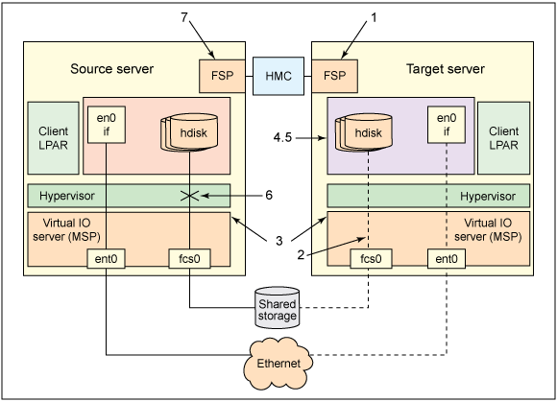
Figure 3.1 Live Partition Migration Architecture

4. TECHNICAL DESCRIPTION
VAADIN:
Vaadin is an open source Java Web application framework for rich Internet applications. In contrast to JavaScript libraries and browser-plugin based solutions, it features a server-side architecture, which means that the majority of the logic runs on the servers. Ajax technology is used at the browser-side to ensure a rich and interactive user experience. On the client-side Vaadin is built on top of and can be extended with Google Web Toolkit.
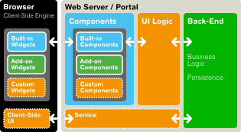

Figure 4.1 Vaadin Application Architecture
The figure 4.1 illustrates the architecture of web applications developed with Vaadin. The server-side application architecture consists of the server-side framework and a client-side engine. The engine runs in the browser as JavaScript code, rendering the user interface, and delivering user interaction to the server. The UI logic of an application runs as a Java Servlet in a Java application server.
As the client-side engine is executed as JavaScript in the browser, no browser plugins are needed for using applications made with Vaadin. Vaadin makes use of AJAX (Asynchronous JavaScript and XML) techniques that make it possible to create Rich Internet Applications (RIA) that are as responsive and interactive as desktop applications. The Vaadin client-side framework includes Google Web Toolkit (GWT), which provides a compiler from Java to the JavaScript that runs in the browser, as well a full-featured user interface framework.
Vaadin's default component set can be extended with custom GWT widgets and themed with CSS. Vaadin is distributed as a collection of JAR files which can be included in any kind of Java web project developed with standard Java tools.
RESTFUL WEB SERVICES:
REST defines a set of architectural principles to design Web Services that focus on a system's resources, including how resource states are addressed and transferred over HTTP by a wide range of clients written in different languages. The implementation of a REST Web service follows the basic design principles:
- Use of HTTP methods
- Being stateless
Use of HTTP methods
One of the key characteristics of a RESTful Web service is the explicit use of HTTP methods in a way that it follows the protocol as defined by RFC 2616. The basic REST design principle establishes a one-to-one mapping between create, read, update, and delete (CRUD) operations and HTTP methods. According to this mapping:
- To create a resource on the server, use POST.
- To retrieve a resource, use GET.
- To change the state of a resource or to update it, use PUT.
- To remove or delete a resource, use DELETE.
The parameter names and values on the request URI are converted into XML tags and are sent in the body of the HTTP method.
Being stateless
REST Web services need to scale to meet increasingly high performance demands. Clusters of servers with load-balancing and failover capabilities, proxies, and gateways are typically arranged in a way that forms a service topology, which allows requests to be forwarded from one server to the other as needed to decrease the overall response time of a Web service call. Using intermediary servers to improve scale requires REST Web service clients to send complete, independent requests; that is, to send requests that include all data needed to be fulfilled so that the components in the intermediary servers may forward, route, and load-balance without any state being held locally in between requests.
A REST Web service application (or client) includes within the HTTP headers and body of a request all of the parameters, context, and data needed by the server-side component to generate a response. Statelessness in this sense improves Web service performance and simplifies the design and implementation of server-side components because the absence of state on the server removes the need to synchronize session data with an external application.
Stateless server-side components are less complicated to design, write, and distribute across load-balanced servers. A stateless service not only performs better, it shifts most of the responsibility of maintaining state to the client application. In a RESTful Web service, the server is responsible for generating responses and for providing an interface that enables the client to maintain application state on its own. Being stateless thus improves performance by saving bandwidth and minimizing server-side application state.
5. IMPLEMENTATION DESCRIPTION
5.1 MIGRATION
The managed system or the server whose logical partitions have to be live migrated is employed to invoke the Migration task. Figure 5.1 shows the 'Migrate' task listed in the Server menu. The Migration process involves the sub-processes namely LPAR list loading, Migration planning, plan validation, LPAR Migration and plan export.
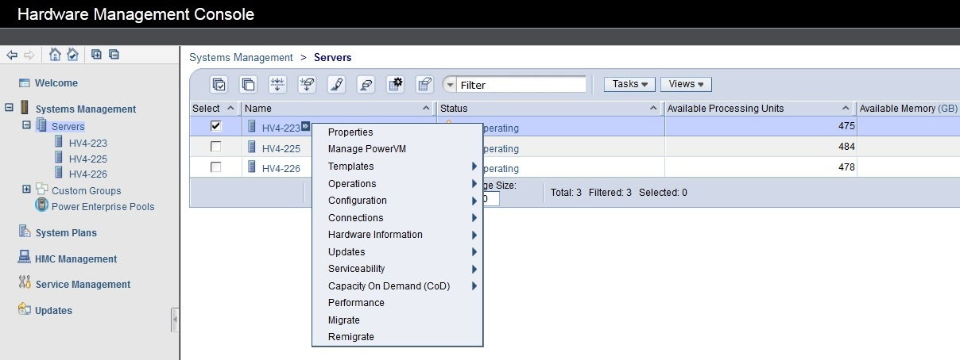
Figure 5.1 Migrate task invocation
LPAR List Loading:
The Hardware Management Console is capable of maintaining a number of managed systems, each with their logical partitions. We consider migrating the LPARs of the server only to the managed systems that are maintained by the HMC, which maintains the source server (i.e We consider only the LPAR migration for managed systems under single HMC). The list of LPARs belonging to the source server are fetched using the HMC details by the REST client. Rest client in turn uses Apache Wink which is a solid framework for building RESTful Web services. The extracted details are loaded into the user interface using the bean item container.
Migration Planning:
The listed LPARs are grouped and they are assigned with group numbers. For each group, suitable destination server is chosen, from the list of HMC managed servers. A destination server can be assigned with any number of groups. The groups are assigned by considering the configuration of the destination server. Figure 5.2 shows the assignment of GroupId and Destination.
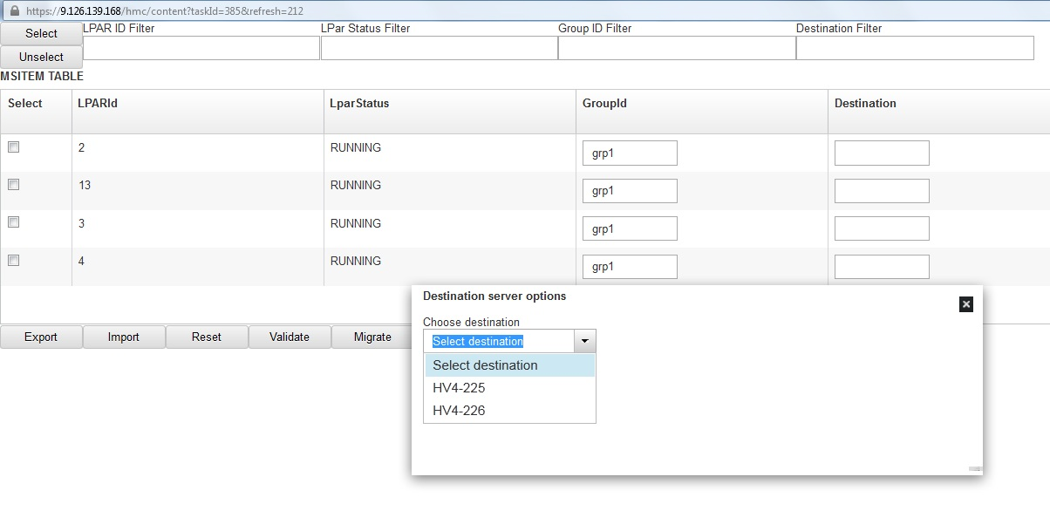
Figure 5.2 Migration planning

Plan Validation:
The plan is validated inorder to know if it is valid or it contains errors. the validation is done by calling the REST job through the REST client. All jobs are executed through Quartz scheduler which is similar to crontab in linux. Values like Universal Unique ID(UUID) of the source managed system, operation name(Validate), operation type(Discrete/continuous) are passed as input to the REST client. Also, job request parameters like SourceManagedSystem name, SourecLparIDs, TargetManagedSystemName are also passed to the REST client. The validation operation is done based on destination server, to check if the server has the configuration required to accommodate the planned groups.
The REST client builds the Uniform Resource Identifier(URI) using the input like UUID, operation name. It marshalls the job request parameters and passes to the REST job. The REST job implements the Command-Line Interface(CLI) command for validation,
migrlpar [-o v -m <source managed system> -t <target managed system>] -p <partition name> |--id <partition ID>[-n <profile name>] [-f <input data file> | -i "<input data>"] [-w <wait time>] [-d <detail level>]
Once the job is called, the job response is returned to the REST client, where the response is unmarshalled and displayed. If the plan has errors, it will be displayed in the user interface against the corresponding logical partition . If the validation has no error for the destination server, it will display the status against the destination in the user interface. In case of error in the plan, then the plan can be modified based on the error description. the validation interface is shown in Figure 5.3.
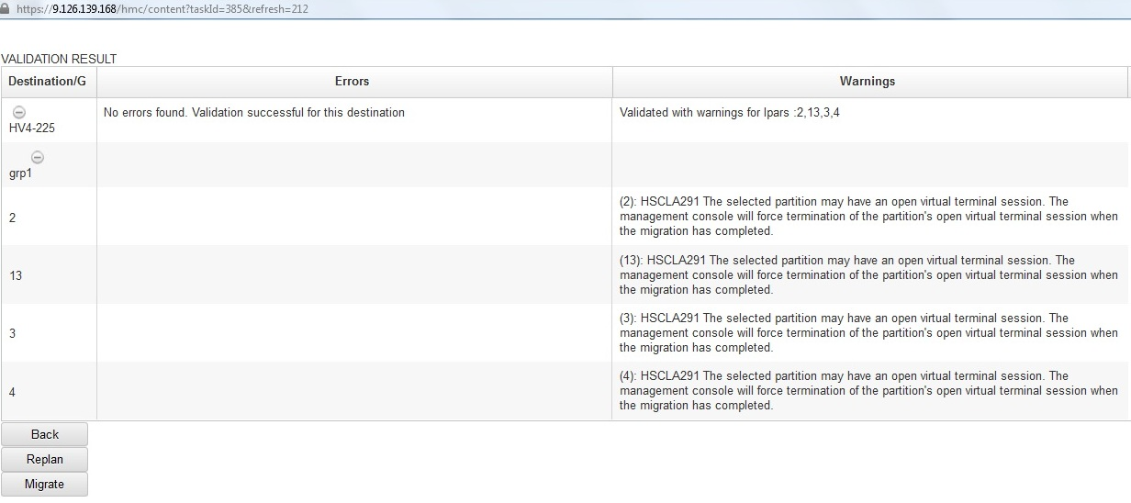
Figure 5.3 Plan Validation Interface
LPAR Migration:
The successfully validated plan can be used for migration, where the REST client calls the REST job to perform the actual migration. The REST client accepts the Rest inputs like UUID, operation name(Migrate), operation type (Discrete/ continuous) and job request parameters like SourceManagedSystem name, SourecLparIDs, TargetManagedSystem name. The validation operation is done based on destination server, to check if the server has the configuration required to accommodate the planned groups.
Singleton class is used to maintain jobId in a blocking queue as well as thread pool to call polling if many jobs are submitted in parallel. There are cases where many users might have logged in to the same HMC and might want to migrate lpars from different sources. In that sense, Singleton class is highly useful in maintaining the jobids of different users in a single Blocking Queue.
Blocking Queue is one that additionally supports operations that wait for the queue to become non-empty when retrieving an element , and wait for space to become available in the queue when storing an element. Blocking Queue implementations are thread safe. Its principle is similar to producer consumer problem.
Thread pool is a pattern where number of threads are created to perform a number of tasks , which are usually organized in a queue. Thread pool consists of worker threads. Thread pool minimizes the overhead due to thread creation. Thread objects use a significant large amount of memory and in a large scale application, allocating and deallocating many thread objects creates a significant memory management overhead. Tasks are submitted to the pool via an internal queue, which holds extra tasks whenever there are more active tasks than threads.
The REST job implements the CLI command for migration,
migrlpar [-o m -m <managed system> -t <managed system> -p <partition name> |--id <partition ID>[-n <profile name>] [-f <input data file> | -i "<input data>"] [-w <wait time>] [-d <detail level>] [--async] [-v] | [ -redundantpgvios { 0 | 1 | 2 }]
Migration is carried out by calling the REST jobs concurrently, where each job corresponds to a destination server. In the CLI command, the "--id" field contains the comma separated list of logical partitions that are assigned to a particular destination. The execution of the command performs migration of these logical partitions sequentially.
The jobs are called and the response is returned to the REST client which inturn unmarshalls it. From the response the job ID is retrieved and the status of each job is polled using the Job ID. The migration status is tracked by the job, using the CLI command,
lslparmigr -r manager | lpar | msp | procpool | sys | virtualio | mempool | pgdev [-m <managed system] [-t <managed system>] [--ip <target HMC/IVM IP address> [-u <target HMC/IVM username>]] [--filter "<filter data>"] [-F [<attribute names>]] [--redundantpgvios { 0 | 1 | 2 }] [--header] [--help]
The job returns one of the possible values of migration, namely starting, running, completed. The progress is displayed using suitable indicator in the user interface as shown in the Figure 5.4.
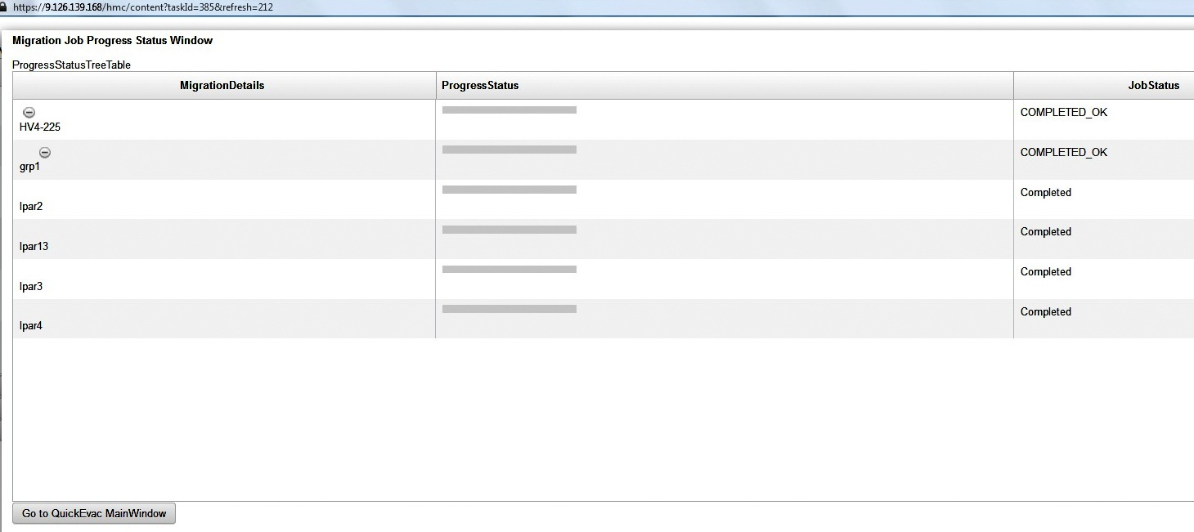
Figure 5.4 Migration Progress Interface
Plan Export:
The migration plan has to be stored in suitable format like XML for future reference. XML schema is prepared and classes are generated from it, which are used for storing the details of logical partitions, LPAR groups, Destination servers. Initially, when the migration plan is prepared, it can be marshalled and stored as XML. Once the migration of all the logical partitions are completed, the Xml file is updated with all the details and stored.The figure 5.5 shows a sample XML file content.
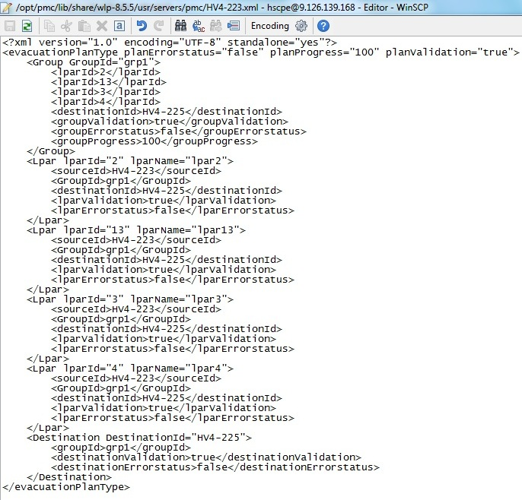
Figure 5.5 Sample exported XML file content
5.2 REMIGRATION:
The logical partitions of the server which are migrated have to be remigrated back to it after maintenance. The server to which the LPARs has to be remigrated is employed to invoke the remigration task. Initially, the XML file is imported and unmarshalled. Based on the values of certain attributes of the generated class, the successfully migrated Logical partitions are extracted and loaded in the user interface as shown in Figure 5.6. The significant attributes are DestinationValidation, GroupValidation, LPARValidation and LPARErrorStatus.
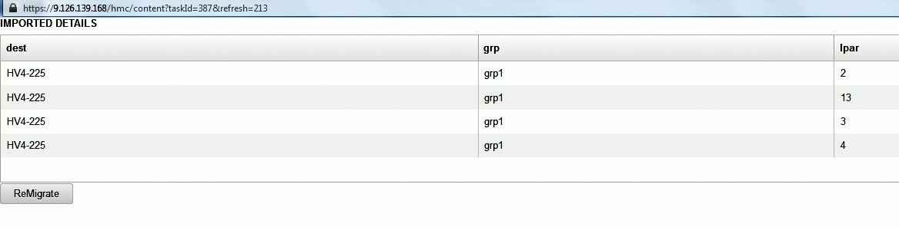
Figure 5.6 Imported details of Migration
For each server, which contains the migrated logical partitions of the Maintained server, the validation of those logical partitions to the Maintained server is done and if validation is successful, the logical partitions are remigrated to the Maintained server. The user interface is updated with the progress of the Remigration job, till all the logical partitions are remigrated.The figure 5.7 shows a sample of the LPARs in the native server after Remigration.
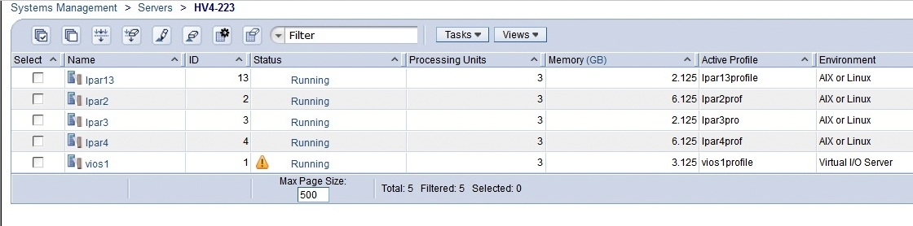
Figure 5.7 Remigrated LPARs on server

6. FUTURE ENHANCEMENT

The project is planned to be enhanced by considering changes to the User Interface. The user interface is designed to make it more interactive and appealing for the users to work on. Also, Soft Validation of the plan has to be carried out to improve the efficiency of Migration by preventing infeasible plan during Planning phase itself.

